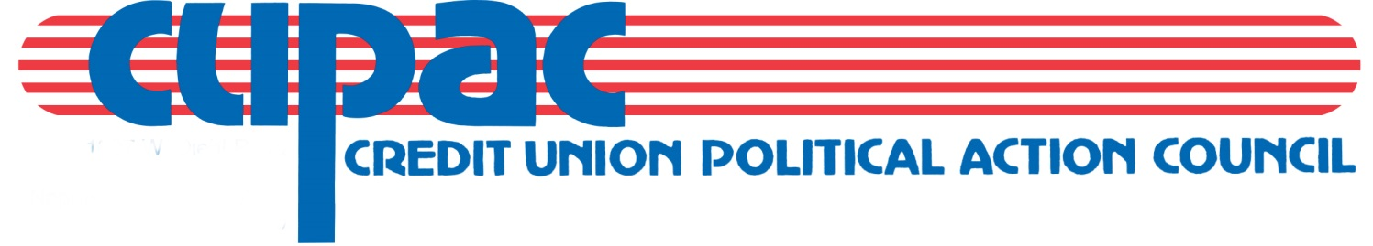

January 12, 2022

TO: Chapter Chairman

RE: CUPAC Chapter Donations (disbursement form)-suggested return date: April 11, 2022

The past year has been a difficult on many levels, including chapter events. However, there is hope on the horizon that regular group activities can return. It is with this optimism that CUPAC is asking chapters to complete & return the yearly forms for 2022.

CUPAC is striving to have all chapters return this annual form. Please help us achieve this.

In order to ensure that funds collected from individuals as a result of chapter fundraising activities may be used to make political contributions, it will be necessary for you, as chapter Chairman, to complete the enclosed disbursement form. This form will allow us to report fundraising money as individual contributions regardless of whether or not they are written on chapter checks. This is merely a recordkeeping device for the Credit Union Political Action Council.

Due to the strict rules and regulations that govern political action committees, we must keep accurate records with regard to individual/credit union/chapter contributions. Money collected from chapter-sponsored events such as raffles, golf outings and auctions are, in fact, individual funds, not chapter funds, and as such are treated differently for accounting and reporting purposes.

Your assistance in this matter will be greatly appreciated. Thank you for your support of CUPAC.

Sincerely,
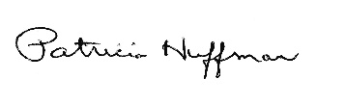
Pat Huffman, Political Action Director
Governmental Affairs

Contributions to CUPAC are not deductible as charitable contributions for federal income tax purposes. A copy of our report filed with the State Board of Elections is (or will be) available on the Board’s official website (www.elections.il.gov) or for purchase from the State Board of Elections in Springfield, Illinois. Contributions are strictly voluntary and you have the right to refuse to contribute without reprisal.
CHAPTER DISBURSEMENTS TO CUPAC
2022

CUPAC, from time to time, solicits and receives money from this Chapter. The moneys received and remitted to CUPAC through a Chapter share draft or check represents contributions collected from individuals by the Chapter. CUPAC will treat such remittances as contributions from individuals unless the Chapter otherwise designates, on the face of the check or share draft, that the funds are from the Chapter treasury for a Chapter donation.

__________________________________________________________
Chapter

________________________________________________ __________
Signature of Chapter Chairman Date

Thank you for your commitment to CUPAC.

Please return to:

Pat Huffman, Political Action Director
Governmental Affairs
Illinois Credit Union League
1807 W. Diehl Road
Naperville, IL 60563
F: 630-983-2713
E: pat.huffman@icul.com

SUGGESTED RETURN DATE: April 11, 2022
(however, accepted at any time)

Contributions to CUPAC are not deductible as charitable contributions for federal income tax purposes. A copy of our report filed with the State Board of Elections is (or will be) available on the Board’s official website (www.elections.il.gov) or for purchase from the State Board of Elections in Springfield, Illinois. Contributions are strictly voluntary and you have the right to refuse to contribute without reprisal. The above amounts are suggested giving levels. More or less may be contributed.

