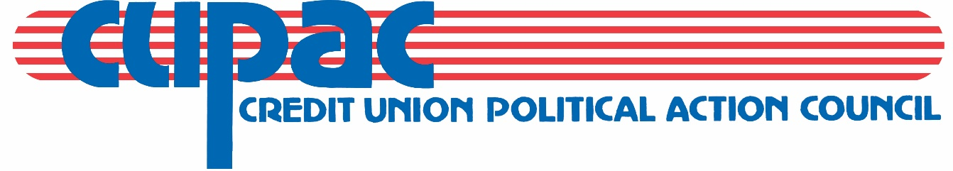

2022 CUPAC CHAPTER COMPETITION PLEDGE FORM

Pledging is part of the Chapter Competition program wherein Chapters compete with each other to raise funds for CUPAC. The Chapter is not under any obligation to reimburse CUPAC for pledge amounts not raised; the pledge merely serves as a goal for the Chapter to work towards.

_____________________________________ $_________________________________
Chapter Amount Pledged

_______________________________________ _________________________________
Signature of Chapter Chairman Date

Thank you for your commitment to CUPAC.

Return to:

Pat Huffman, Political Action Director
Governmental Affairs
Illinois Credit Union League
1807 W. Diehl Road
Naperville, IL 60563
Fax: 630-983-2713
Email: pat.huffman@icul.com

REQUESTED RETURN DATE: MARCH 15, 2022
(However, accepted at any time)

Contributions to CUPAC are not deductible as charitable contributions for federal income tax purposes. A copy of our report filed with the State Board of Elections is (or will be) available on the Board’s official website (www.elections.il.gov) or for purchase from the State Board of Elections in Springfield, Illinois. Contributions are strictly voluntary and you have the right to refuse to contribute without reprisal. The above amounts are suggested giving levels. More or less may be contributed.

