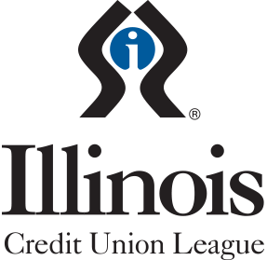

FOR IMMEDIATE RELEASE

Media Contact
Melissa Vidito
Illinois Credit Union System
773-203-4181
melissa.vidito@envisant.com

Illinois Credit Union League CU Kind® Day
Helps Support Nearly 400 Local Organizations

Naperville, Illinois (October 17, 2022) – A record-breaking seventy-eight Illinois credit unions and partners joined forces with the Illinois Credit Union League (ICUL) on October 10, 2022 for CU Kind Day, a state-wide initiative to spread kindness. Demonstrating the shared core value of “people helping people,” those within the Illinois credit union movement rolled up their sleeves and harnessed the power of cooperation to support their local communities.

CU Kind Day united 2,900 credit union volunteers under a shared mission to empower their communities. Together, they supported 395 community organizations within Illinois and generated more than $93,000 in goods and donations. Their efforts included giving monetary donations; online wish list shopping; collecting drives for food and needed goods, volunteering at local organizations; donating classroom needs, supporting local shelters; delivering care packages; and much more.

“I’m inspired to see how the community impact of CU Kind Day has grown even through challenging times. It demonstrates that nothing can stop our Illinois credit unions in fulfilling their mission to serve their members and communities first,” said ICUL President/CEO Tom Kane. “I’m honored to be part of this movement and grateful for the chance to bring Illinois credit unions together for CU Kind Day. It’s an important way to inspire more acts of kindness while showing individuals within our communities that credit unions are here for them.”

ICUL launched CU Kind Day in 2019 with the purpose of spreading kindness and generating awareness for the good work credit unions do in their communities and for their members.

To learn more about CU Kind, please visit www.icul.com/cu-kind.

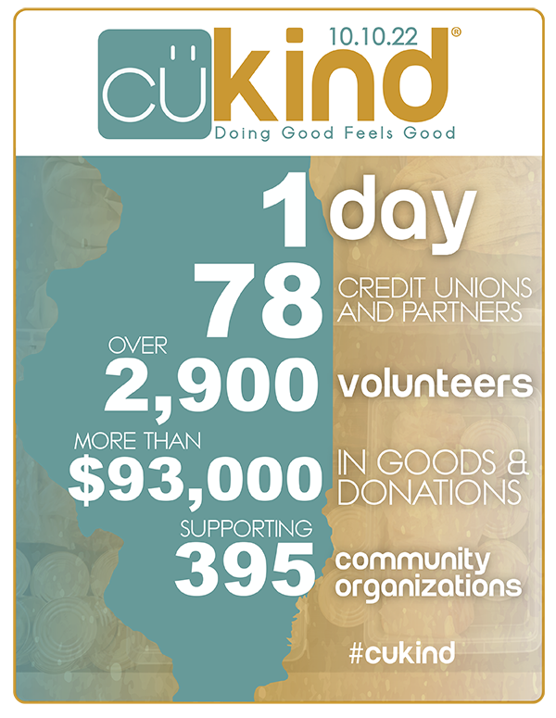
###

About the Illinois Credit Union League
The Illinois Credit Union League is the primary trade association for more than 200 state and federal credit unions in Illinois. It focuses on providing legislative and regulatory advocacy, compliance assistance and information, and a wide range of educational and training services to those credit unions, who in turn serve approximately 3.4 million members. More information can be found at www.icul.com.

1807 W. Diehl Rd.
P.O. Box 3107
Naperville, Illinois
60566-7107
(800) 942-7124
(630) 983-3400
(630) 983-4284 Fax
www.iculeague.coop
Springfield Branch
225 S. College Ave., Suite 200
Springfield, IL 62704
(217) 744-1800

